**Power BI Project 3 Result Summary**

## What is the correlation between sales and income?

* Sales and income are positively correlated, with a correlation coefficient of **0.78**. This means that higher sales tend to lead to higher income.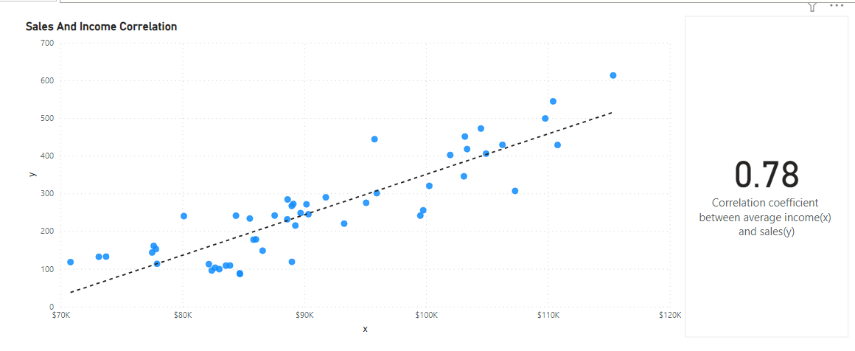

## What is the correlation (R2 value) between customer ratings and product return rate?

* Products with higher customer ratings have lower return rates, with a correlation coefficient of **-0.83**.

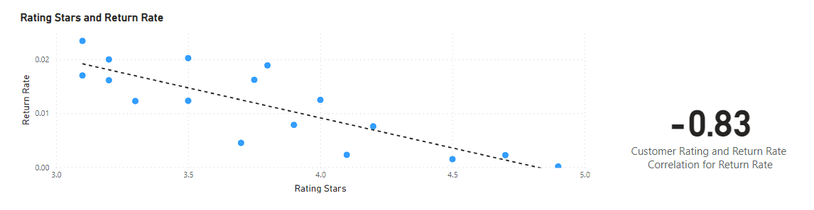

## What are the linear regression formulas to predict customer income from customer sales?

**x = -722.14 – y / -m**

## Which customer do you predict has the highest income?

* **Jon Little** is predicted to be the highest income earner, based on the regression formula:

**x = -722.14 – y / -m**

* This was determined by filtering the top 1 earner.

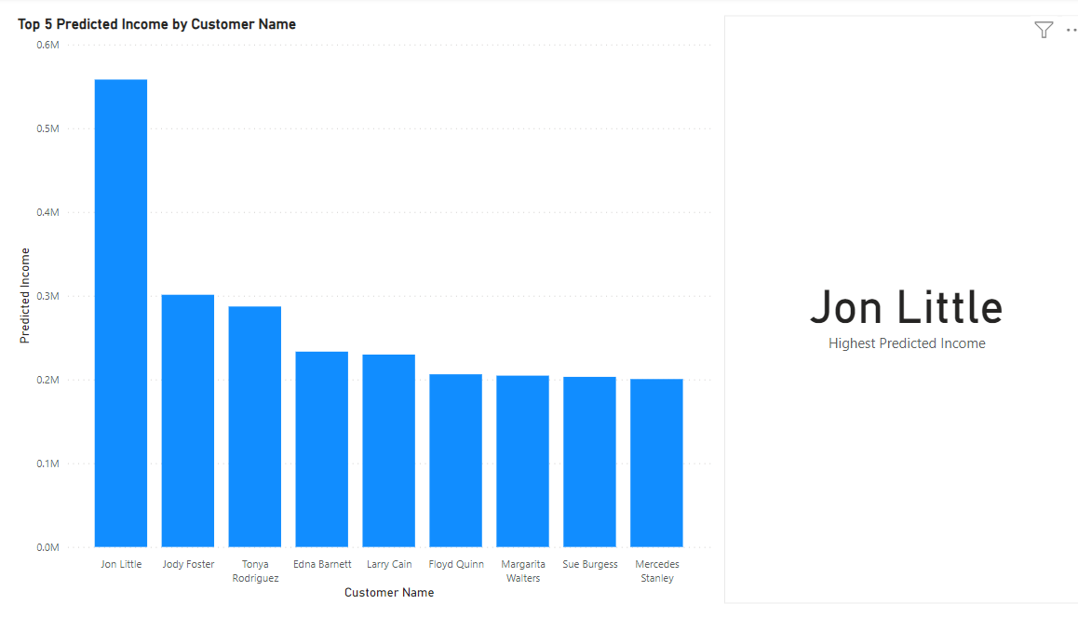

## Which product will be advertised the most?

* The **Chronograph Watch** will be advertised the most. It is the best rated product with a rating of **4.90**, and there is a strong negative correlation between customer ratings and product return rate. This means that products with higher ratings tend to be returned less often, so the Chronograph Watch is likely to be a popular product with customers.
* In addition, the Chronograph Watch is a relatively expensive product. Businesses typically want to advertise their most profitable products, so the Chronograph Watch is a good candidate for advertising.

